

2024
World AgriFood Innovation Conference World AgriFood Technology Expo









Conference&Expo : October 10-12, 2024
Location : Beijing ,China
PARTNERSHIP OVERVIEW
Coffee Break Luncheon
Luncheon
Sponsorship
OPPORTUNITIES

2024 WORLD AGRIFOOD

INNOVATION CONFERENCE






ADs
Gala Dinner
Cocktail Reception
Stakeholder Forums
Parallel Sub-forums
Web Ads Physical Advertising
Main Forum
Materials & Gifts
Side-
events
Working Sessions
Closed Meetings
Corporate Presentations
Breakout Sessions

Opportunities
Exhibition
National Pavilion
Industry Pavilion
Corporate VIP Booths


COOPERATION PROGRAMMES

I nnovati ng Agr i food Shar i ng Futur e

Cooperation Categories & Returns |  | Global Partner | Lead Partner | Strategic Partner | Industry Partner | Supporting Patner | Sub forum Organizor | Sub forum Partner
Cooperation Amount |  | 3,000,000 | 2,000,000 | 1,000,000 | 500,000 | 300,000 | 100,000 | 50,000
Exhibition | Booth | 225m ² | 135m ² | 90m ² | 72m ² | 54m ² | 18m ² | 9m ²
Badges | VIP | 6 | 4 | 2 | 1 | 1
Badges | Free Pass | 20 | 15 | 10 | 5 | 5 | 5 | 2
Special Offers | Listed as Partner
Special Offers | Awards & Certificates
Special Offers | Registration Board +  Logo
Special Offers | Thanks Banner
Special Offers | Welcome Dinner
Ads | Website + Logo
Ads | Guidebook + Logo
Ads | Giant Billboards | 1 piece | 1 piece | 1 piece | 1 piece | 1 piece
Ads | Lightbox Ad | 2 pieces | 1 piece
Ads | Ad Banner | 2 pieces | 1 piece |  |  |  | 2 pieces | 1 piece
Ads | Guidebook Ad | 2 pieces | 2 pieces | 1 piece | 1 piece | 1 piece | 1 piece | 1 piece

COOPERATION PROGRAMMES

I nnovati ng Agr i food Shar i ng Futur e

Cooperation categories and returns |  | Global Partner | Lead Partner | Strategic Partner | Industry Partner | Supporting Patner | Sub forum Organizor | Sub forum Partner
Cooperation amount |  | 3 million | 2 million | 1 million | 500 thousand | 300 thousand | 100 thousand | 50 thousand
Exclusive Benefits | Join Advisory Committee
Exclusive Benefits | Promotional Materials
Exclusive Benefits | Promotional Video | 3 minutes | 2 minutes | 1 minute | 1 minute |  | 1 minute
Exclusive Benefits | Main Forum
Exclusive Benefits | Stakholders Forum | Keynote | Dialogue |  | Logo
Exclusive Benefits | Parallel Sub Forum |  |  |  | Keynote | Keynote | Keynote | Dialogue
Exclusive Benefits | Pre-event Dialogue | Phase 1 | Phase 1 | Phase 1
Exclusive Benefits | Mesh Display Ad | 3 pieces | 3 pieces |  |  |  | 1 unit
Exclusive Benefits | Guidebook + Logo
Exclusive Benefits | Media Interviews
Exclusive Benefits | Opening Ceremony
Exclusive Benefits | Welcome Meeting
Exclusive Benefits | Free Meeting Room

REGISTRATION FEE

Early Bird Price

Regular Price
I nnovati ng Agr i food Shar i ng Futur e

Late Registration

3200 ¥/person
(500 ＄/person)

Before July 1st

3200 ¥/person
(500 ＄/person)
July 2nd -September 1st

3200 ¥/person
(500 ＄/person)

After September 2nd

GET NOW
GET NOW
GET NOW

Note: The opening ceremony is only open to invited representatives

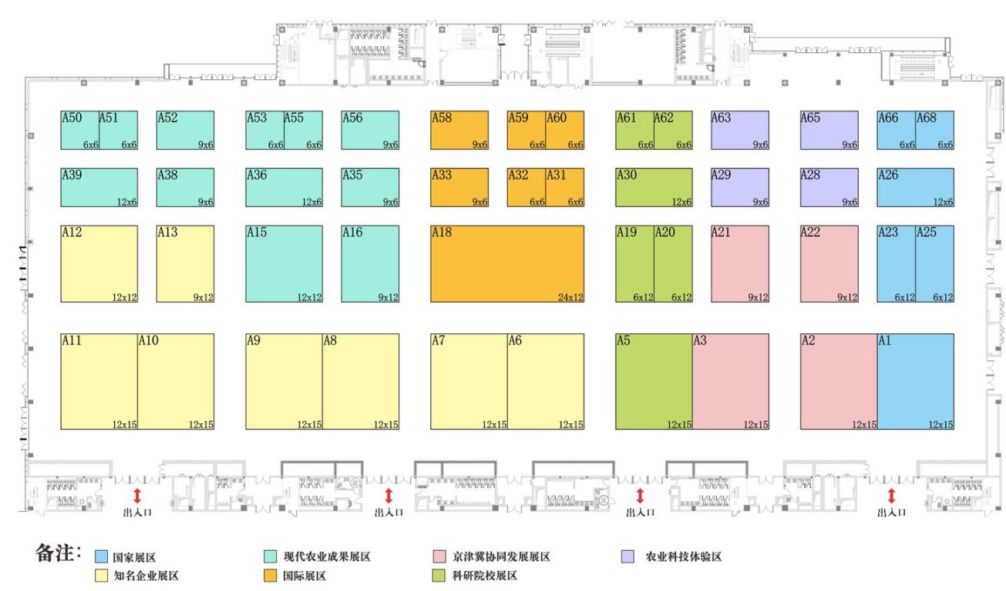
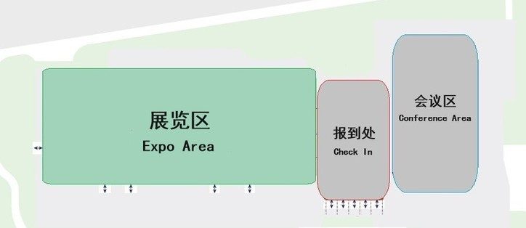
WAFI EXPO
I n n o v ati n g Ag r i fo o d Sh ar i n g Fu tu r e

Booth Fees:
Raw Space: 1280 RMB / ㎡
Shell Scheme: 12800 RMB / 9㎡



“ Join Us!
Focusing on climate change,
Leading the transformation of agrifood；
Innovating agricultural technology, and Sharing a green future!
““




WAFI Organizing Committee Email: alicia.abu@wafiforum.com Web: http://en.wafiforum.com/ Tel: 86-17710860813
Fax: 86-010-62927691
Address: 9F, Block A, Golden Horse Mansion, No.A38, Xueqing Road, Haidian District, Beijing, P.R. China

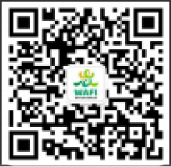

扫码关注了解更多⼤会详情

